Type the title of your paper here
List the author names here. Use the following style: John C Michel*, Ahmed N Jamal and Rami S Kevin
Type the author addresses here

Corresponding author’s e-mail:
Abstract. Start your abstract here…
- Introduction
The first paragraph after a heading is not indented (Bodytext style).
Other paragraphs are indented (BodytextIndented style). Use the following reference style [1] and [2, 3].
- Materials and Methods
The first paragraph after a heading is not indented (Bodytext style).
Other paragraphs are indented (BodytextIndented style).

A subsection
Some text.
    - A subsubsection. The paragraph text follows on from the subsubsection heading but should not be in italic.
- Results and Discussion
The first paragraph after a heading is not indented (Bodytext style).
Other paragraphs are indented (BodytextIndented style).
  - A subsection
Some text.
    - A subsubsection. The paragraph text follows on from the subsubsection heading but should not be in italic.

Table 1. Response of wounded detached leaves of various plant species to the Macrophomina phaseolina inoculation
Plant Species | % Detached Leaf Damage *
 | Control* | Treated*
Giradol Chrozophora tinctoria | 0.0 | 0.00
Christ's thorn jujube Ziziphus spina-christi | 0.0 | 33.3
Rose Rosa amascenad | 0.0 | 75.5
Oleander Nerium oleander | 0.0 | 46.8
Hop bush Dodonaea viscosa | 0.0 | 65.5
LSD at 0.05 | 11.25
Notes: Results taken after five days each value is an average of three replicates.

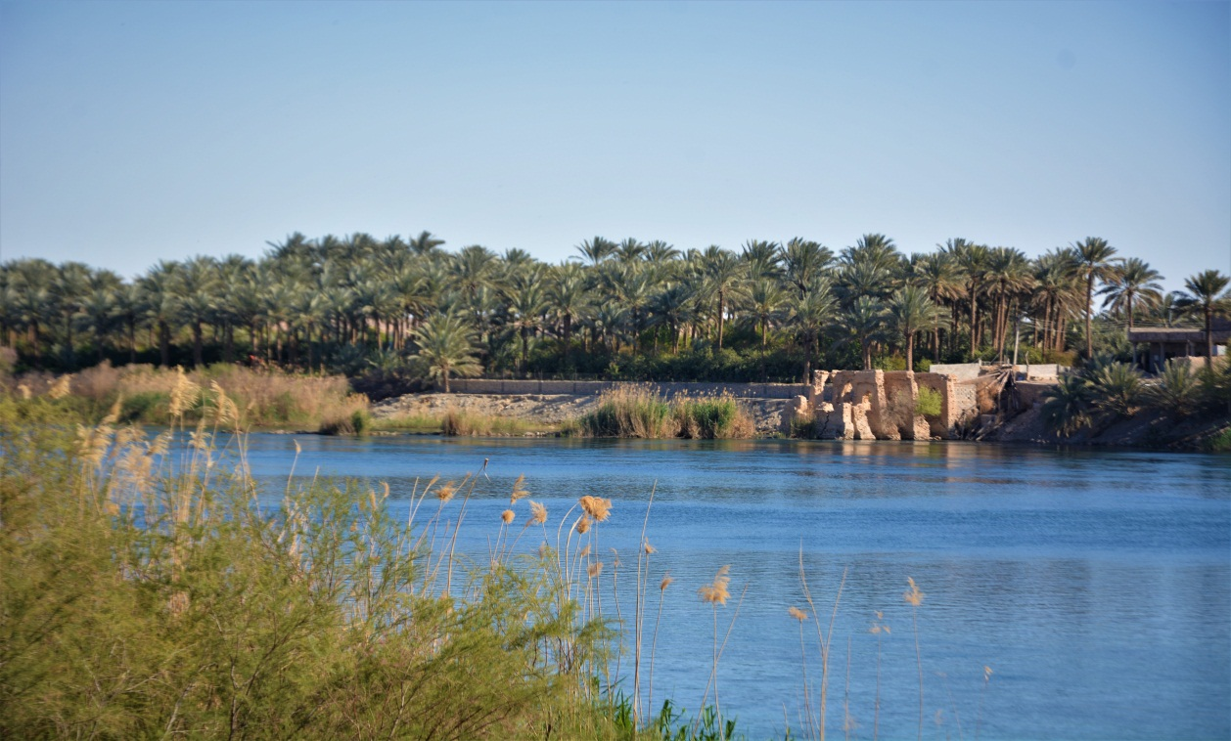

Figure 1. Euphrates river.

- Conclusion
The first paragraph after a heading is not indented (Bodytext style).
References
- Chaudhary, D, Mohammad SK, Shah AP, and Yadav AP 2019, Antifungal activity of three different ethanoic extract against isolates from diseased rice plant. Journal of Analytical Techniques and Research 1, 047-063.
- Gupta, GK, Sharma, SK, and Ramteke, R 2012, Biology, epidemiology, and management of the pathogenic fungus Macrophomina phaseolina (Tassi) Goid with special reference to charcoal rot of soybean (Glycine max (L.) Merrill). Journal of Phytopathol. 160, 167–180.
- More references……

